**\*\*\*\*\*\*\*\*\*\*\*\*\*\*\*\*\*\*\*\*\*\*\*\*\*\*\*\*\*\*\*\*\*\*\*\*\*\*\*\*\*\*\*\*\*\*\*\*\*\*\*\*\*\*\*\*\*\*\*\*\*\*\*\*\*\*\*\*\*\*\*\*\*\*\* Assignment No. 01**

**Name of Student:** Rupesh Ramesh Desai **Roll No.:**

**Class:** B.Sc III **Date: / /**

**Signature:**

**\*\*\*\*\*\*\*\*\*\*\*\*\*\*\*\*\*\*\*\*\*\*\*\*\*\*\*\*\*\*\*\*\*\*\*\*\*\*\*\*\*\*\*\*\*\*\*\*\*\*\*\*\*\*\*\*\*\*\*\*\*\*\*\*\*\*\*\*\*\*\*\*\*\*\***

**Q. Write an ASP.Net Program to print a Message on web form**

**Program:**

<%@ Page Language="C#" AutoEventWireup="true" CodeBehind="form1.aspx.cs" Inherits="Assignmentno1.form1" %>

<!DOCTYPE html PUBLIC "-//W3C//DTD XHTML 1.0 Transitional//EN" "http://www.w3.org/TR/xhtml1/DTD/xhtml1-transitional.dtd">

<html xmlns="http://www.w3.org/1999/xhtml">

<head runat="server">

<title></title>

</head>

<body>

<form id="form1" runat="server">

<div>

<%

Response.Write("Hello!....");

Response.Write("We are in Computer lab");

%>

<br />

<br />

</div>

</form>

</body>

</html>

**\*\*\*\*\*\*\*\*\*\*\*\*\*\*\*\*\*\*\*\*\*\*\*\*\*\*\*\*\*\*\*\*\*OUTPUT\*\*\*\*\*\*\*\*\*\*\*\*\*\*\*\*\*\*\*\*\*\*\*\*\*\*\*\*\*\*\*\*\***

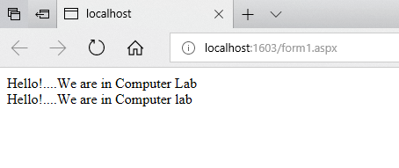

**\*\*\*\*\*\*\*\*\*\*\*\*\*\*\*\*\*\*\*\*\*\*\*\*\*\*\*\*\*\*\*\*\*\*\*\*\*\*\*\*\*\*\*\*\*\*\*\*\*\*\*\*\*\*\*\*\*\*\*\*\*\*\*\*\*\*\*\*\*\*\*\*\*\*\* Assignment No. 02**

**Name of Student:** Rupesh Ramesh Desai **Roll No.:**

**Class:** B.Sc III **Date: / /**

**Signature:**

**\*\*\*\*\*\*\*\*\*\*\*\*\*\*\*\*\*\*\*\*\*\*\*\*\*\*\*\*\*\*\*\*\*\*\*\*\*\*\*\*\*\*\*\*\*\*\*\*\*\*\*\*\*\*\*\*\*\*\*\*\*\*\*\*\*\*\*\*\*\*\*\*\*\*\***

**Q. Write an ASP.Net Program to Create Simple Web Application using two or more web form.**

**Program:**

WebForm1

<%@ Page Language="C#" AutoEventWireup="true" CodeBehind="WebForm1.aspx.cs" Inherits="WebApplication2.WebForm1" %>

<!DOCTYPE html PUBLIC "-//W3C//DTD XHTML 1.0 Transitional//EN" "http://www.w3.org/TR/xhtml1/DTD/xhtml1-transitional.dtd">

<html xmlns="http://www.w3.org/1999/xhtml">

<head runat="server">

<title></title>

</head>

<body>

<form id="form1" runat="server">

<div>

<% Response.Write("Welcome to Dr.Ghali College"); %>

<asp:Button ID="Button1" runat="server" onclick="Button1_Click" Text="Button" />

</div>

</form>

</body>

</html>

WebForm2

<%@ Page Language="C#" AutoEventWireup="true" CodeBehind="WebForm2.aspx.cs" Inherits="WebApplication2.WebForm2" %>

<!DOCTYPE html PUBLIC "-//W3C//DTD XHTML 1.0 Transitional//EN" "http://www.w3.org/TR/xhtml1/DTD/xhtml1-transitional.dtd">

<html xmlns="http://www.w3.org/1999/xhtml">

<head runat="server">

<title></title>

</head>

<body>

<form id="form1" runat="server">

<div>

<% Response.Write("Welcome to 2nd page"); %>

<asp:Button ID="Button1" runat="server" onclick="Button1_Click" Text="Button" />

</div>

</form>

</body>

</html>

Webform 3

<%@ Page Language="C#" AutoEventWireup="true" CodeBehind="WebForm3.aspx.cs" Inherits="WebApplication2.WebForm3" %>

<!DOCTYPE html PUBLIC "-//W3C//DTD XHTML 1.0 Transitional//EN" "http://www.w3.org/TR/xhtml1/DTD/xhtml1-transitional.dtd">

<html xmlns="http://www.w3.org/1999/xhtml">

<head runat="server">

<title></title>

</head>

<body>

<form id="form1" runat="server">

<div>

<%Response.Write("Welcome to Computer lab"); %>

</div>

</form>

</body>

</html>

Webform1.aspx.cs

using System.Web;

using System.Web.UI;

using System.Web.UI.WebControls;

namespace WebApplication2

{

public partial class WebForm1 : System.Web.UI.Page

{

protected void Page_Load(object sender, EventArgs e)

{

}

protected void Button1_Click(object sender, EventArgs e)

{

Response.Redirect("WebForm2.aspx");

}

}

}

Webform1.aspx.cs

using System.Web;

using System.Web.UI;

using System.Web.UI.WebControls;

namespace WebApplication2

{

public partial class WebForm2 : System.Web.UI.Page

{

protected void Page_Load(object sender, EventArgs e)

{

}

protected void Button1_Click(object sender, EventArgs e)

{

Response.Redirect("WebForm3.aspx");

}

}

}

**\*\*\*\*\*\*\*\*\*\*\*\*\*\*\*\*\*\*\*\*\*\*\*\*\*\*\*\*\*\*\*\*\*OUTPUT\*\*\*\*\*\*\*\*\*\*\*\*\*\*\*\*\*\*\*\*\*\*\*\*\*\*\*\*\*\*\*\*\***

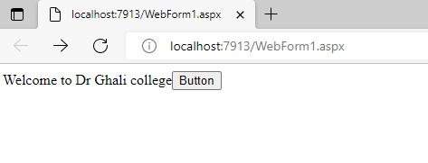

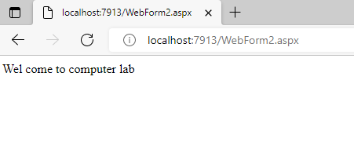

**\*\*\*\*\*\*\*\*\*\*\*\*\*\*\*\*\*\*\*\*\*\*\*\*\*\*\*\*\*\*\*\*\*\*\*\*\*\*\*\*\*\*\*\*\*\*\*\*\*\*\*\*\*\*\*\*\*\*\*\*\*\*\*\*\*\*\*\*\*\*\*\*\*\*\* Assignment No. 03**

**Name of Student:** Rupesh Ramesh Desai **Roll No.:**

**Class:** B.Sc III **Date: / /**

**Signature:**

**\*\*\*\*\*\*\*\*\*\*\*\*\*\*\*\*\*\*\*\*\*\*\*\*\*\*\*\*\*\*\*\*\*\*\*\*\*\*\*\*\*\*\*\*\*\*\*\*\*\*\*\*\*\*\*\*\*\*\*\*\*\*\*\*\*\*\*\*\*\*\*\*\*\*\***

**Q. Write an ASP.Net Program to set a link for new Page.**

**Program:**

<%@ Page Language="C#" AutoEventWireup="true" CodeBehind="Form2.aspx.cs" Inherits="Assignmentno2.Form2" %>

<!DOCTYPE html PUBLIC "-//W3C//DTD XHTML 1.0 Transitional//EN" "http://www.w3.org/TR/xhtml1/DTD/xhtml1-transitional.dtd">

<html xmlns="http://www.w3.org/1999/xhtml">

<head runat="server">

<title></title>

</head>

<body>

<form id="form1" runat="server">

<div>

<%

Response.Write("This is First Page");

%>

<asp:Button ID="Button1" runat="server" onclick="Button1_Click" Text="Button" />

</div>

</form>

</body>

</html>

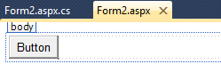

using System;

using System.Collections.Generic;

using System.Linq;

using System.Web;

using System.Web.UI;

using System.Web.UI.WebControls;

namespace Assignmentno2

{

public partial class Form2 : System.Web.UI.Page

{

protected void Page_Load(object sender, EventArgs e)

{

}

protected void Button1_Click(object sender, EventArgs e)

{

Response.Redirect("WebForm2.aspx");

}

}

}

**\*\*\*\*\*\*\*\*\*\*\*\*\*\*\*\*\*\*\*\*\*\*\*\*\*\*\*\*\*\*\*\*\*OUTPUT\*\*\*\*\*\*\*\*\*\*\*\*\*\*\*\*\*\*\*\*\*\*\*\*\*\*\*\*\*\*\*\*\***

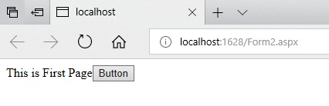

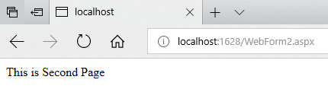

**\*\*\*\*\*\*\*\*\*\*\*\*\*\*\*\*\*\*\*\*\*\*\*\*\*\*\*\*\*\*\*\*\*\*\*\*\*\*\*\*\*\*\*\*\*\*\*\*\*\*\*\*\*\*\*\*\*\*\*\*\*\*\*\*\*\*\*\*\*\*\*\*\*\*\* Assignment No. 04**

**Name of Student:** Rupesh Ramesh Desai **Roll No.:**

**Class:** B.Sc III **Date: / /**

**Signature:**

**\*\*\*\*\*\*\*\*\*\*\*\*\*\*\*\*\*\*\*\*\*\*\*\*\*\*\*\*\*\*\*\*\*\*\*\*\*\*\*\*\*\*\*\*\*\*\*\*\*\*\*\*\*\*\*\*\*\*\*\*\*\*\*\*\*\*\*\*\*\*\*\*\*\*\***

**Q. Write an ASP.Net Program to demonstrate different common Control.**

**Program:**

<%@ Page Language="C#" AutoEventWireup="true" CodeBehind="Assignment5.aspx.cs" Inherits="Assignment_5.Assignment5" %>

<!DOCTYPE html PUBLIC "-//W3C//DTD XHTML 1.0 Transitional//EN" "http://www.w3.org/TR/xhtml1/DTD/xhtml1-transitional.dtd">

<html xmlns="http://www.w3.org/1999/xhtml">

<head runat="server">

<title></title>

</head>

<body>

<form id="form1" runat="server">

<div>

<asp:Label ID="Label1" runat="server" Text="Name"></asp:Label>

&nbsp;&nbsp;&nbsp;&nbsp;&nbsp;&nbsp;&nbsp;&nbsp;&nbsp;&nbsp;&nbsp;&nbsp;&nbsp;&nbsp;&nbsp;&nbsp;&nbsp; &nbsp; &nbsp;

<asp:TextBox ID="TextBox1" runat="server"></asp:TextBox>

<br />

<br />

<asp:Label ID="Label2" runat="server" Text="Surname"></asp:Label>

&nbsp;&nbsp;&nbsp;&nbsp;&nbsp;&nbsp;&nbsp;&nbsp;&nbsp;&nbsp;&nbsp;&nbsp;&nbsp;&nbsp; &nbsp;&nbsp;

<asp:TextBox ID="TextBox2" runat="server"></asp:TextBox>

<br />

<br />

<asp:Label ID="Label3" runat="server" Text="Address"></asp:Label>

&nbsp;&nbsp;&nbsp;&nbsp;&nbsp;&nbsp;&nbsp;&nbsp;&nbsp;&nbsp;&nbsp;&nbsp;&nbsp;&nbsp; &nbsp;&nbsp;

<asp:TextBox ID="TextBox3" runat="server"></asp:TextBox>

<br />

<br />

<asp:Label ID="Label4" runat="server" Text="Gender"></asp:Label>

<br />

&nbsp;&nbsp;&nbsp;&nbsp;&nbsp;&nbsp;&nbsp;&nbsp;&nbsp;&nbsp;&nbsp;&nbsp;&nbsp;&nbsp;&nbsp;&nbsp;&nbsp;&nbsp;&nbsp;&nbsp;&nbsp;&nbsp;

<asp:RadioButtonList ID="RadioButtonList1" runat="server"

onselectedindexchanged="RadioButtonList1_SelectedIndexChanged">

<asp:ListItem>Male</asp:ListItem>

<asp:ListItem>Female</asp:ListItem>

<asp:ListItem>Other</asp:ListItem>

</asp:RadioButtonList>

<br /> &nbsp;&nbsp;&nbsp;&nbsp;&nbsp;&nbsp;&nbsp;&nbsp;&nbsp;&nbsp;&nbsp;&nbsp;&nbsp;&nbsp;&nbsp;&nbsp;&nbsp;&nbsp;&nbsp; Date of Birth<br />

<asp:Calendar ID="Calendar1" runat="server"></asp:Calendar>

<br />

<br />

&nbsp;&nbsp;&nbsp;&nbsp;&nbsp;&nbsp;&nbsp;

<asp:Button ID="Button1" runat="server" onclick="Button1_Click" Text="Submit" />

</div>

</form>

</body>

</html>

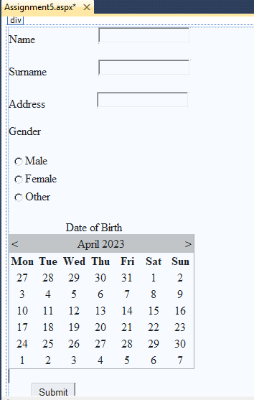

using System;

using System.Collections.Generic;

using System.Linq;

using System.Web;

using System.Web.UI;

using System.Web.UI.WebControls;

namespace Assignment_5

{

public partial class Assignment5 : System.Web.UI.Page

{

protected void Page_Load(object sender, EventArgs e)

{

}

protected void RadioButtonList1_SelectedIndexChanged(object sender, EventArgs e)

{

}

protected void Button1_Click(object sender, EventArgs e)

{

TextBox1.Text = (" ");

TextBox2.Text = (" ");

RadioButtonList1.ClearSelection();

Response.Write("Record Added Successfully");

}

}

}

**\*\*\*\*\*\*\*\*\*\*\*\*\*\*\*\*\*\*\*\*\*\*\*\*\*\*\*\*\*\*\*\*\*OUTPUT\*\*\*\*\*\*\*\*\*\*\*\*\*\*\*\*\*\*\*\*\*\*\*\*\*\*\*\*\*\*\*\*\***

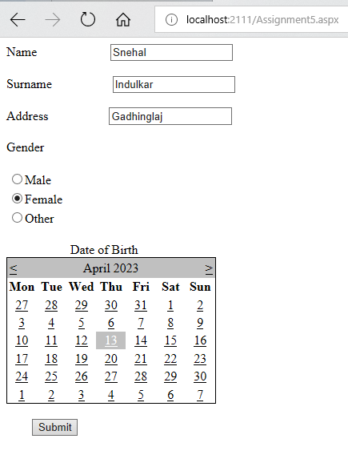

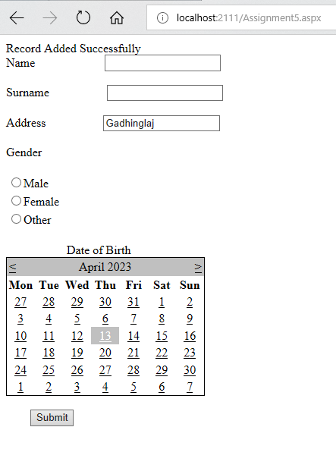

**\*\*\*\*\*\*\*\*\*\*\*\*\*\*\*\*\*\*\*\*\*\*\*\*\*\*\*\*\*\*\*\*\*\*\*\*\*\*\*\*\*\*\*\*\*\*\*\*\*\*\*\*\*\*\*\*\*\*\*\*\*\*\*\*\*\*\*\*\*\*\*\*\*\*\* Assignment No. 05**

**Name of Student:** Rupesh Ramesh Desai **Roll No.:**

**Class:** B.Sc III **Date: / /**

**Signature:**

**\*\*\*\*\*\*\*\*\*\*\*\*\*\*\*\*\*\*\*\*\*\*\*\*\*\*\*\*\*\*\*\*\*\*\*\*\*\*\*\*\*\*\*\*\*\*\*\*\*\*\*\*\*\*\*\*\*\*\*\*\*\*\*\*\*\*\*\*\*\*\*\*\*\*\***

**Q. Write an ASP.Net program using while or for loop to print sum of first 100 Odd and Even numbers.**

**Program:**

<%@ Page Language="C#" AutoEventWireup="true" CodeBehind="Assign5.aspx.cs" Inherits="Assign5.Assign5" %>

<!DOCTYPE html PUBLIC "-//W3C//DTD XHTML 1.0 Transitional//EN" "http://www.w3.org/TR/xhtml1/DTD/xhtml1-transitional.dtd">

<html xmlns="http://www.w3.org/1999/xhtml">

<head runat="server">

<title></title>

</head>

<body>

<form id="form1" runat="server">

<div>

&nbsp;&nbsp;&nbsp;&nbsp;

<asp:Button ID="Button1" runat="server" onclick="Button1_Click"

Text="Addition of even numbers" />

&nbsp;&nbsp;&nbsp;&nbsp;&nbsp;&nbsp;&nbsp;&nbsp;&nbsp;&nbsp;&nbsp;&nbsp;&nbsp;&nbsp;&nbsp;&nbsp;&nbsp;&nbsp;&nbsp;&nbsp;&nbsp;&nbsp;&nbsp;&nbsp;&nbsp;&nbsp;&nbsp;&nbsp;&nbsp;&nbsp;&nbsp;&nbsp;&nbsp;&nbsp;&nbsp;&nbsp;&nbsp;&nbsp;&nbsp;&nbsp;&nbsp;&nbsp;&nbsp;&nbsp;&nbsp;&nbsp;&nbsp;&nbsp;&nbsp;&nbsp;&nbsp;&nbsp;&nbsp;&nbsp;

<asp:Button ID="Button2" runat="server" onclick="Button2_Click"

Text="Addition of odd numbers" />

</div>

&nbsp;&nbsp;&nbsp;&nbsp;&nbsp;

<br />

&nbsp;&nbsp;&nbsp;&nbsp;&nbsp;&nbsp;&nbsp;&nbsp;&nbsp;&nbsp;&nbsp;&nbsp;&nbsp;&nbsp;&nbsp;&nbsp;&nbsp;&nbsp;&nbsp;&nbsp;

<asp:Label ID="Label1" runat="server" Text="Label"></asp:Label>

&nbsp;&nbsp;&nbsp;&nbsp;&nbsp;&nbsp;&nbsp;&nbsp;&nbsp;&nbsp;&nbsp;&nbsp;&nbsp;&nbsp;&nbsp;&nbsp;&nbsp;&nbsp;&nbsp;&nbsp;&nbsp;&nbsp;&nbsp;&nbsp;&nbsp;&nbsp;&nbsp;&nbsp;&nbsp;&nbsp;&nbsp;&nbsp;&nbsp;&nbsp;&nbsp;&nbsp;&nbsp;&nbsp;&nbsp;&nbsp;&nbsp;&nbsp;&nbsp;&nbsp;&nbsp;&nbsp;&nbsp;&nbsp;&nbsp;&nbsp;&nbsp;&nbsp;&nbsp;&nbsp;&nbsp;&nbsp;&nbsp;&nbsp;&nbsp;&nbsp;&nbsp;&nbsp;&nbsp;&nbsp;&nbsp;&nbsp;&nbsp;&nbsp;&nbsp;&nbsp;&nbsp;&nbsp;&nbsp;&nbsp;&nbsp;&nbsp;&nbsp;&nbsp;&nbsp;&nbsp;&nbsp;&nbsp;&nbsp;&nbsp;&nbsp;&nbsp;&nbsp;&nbsp;&nbsp;&nbsp;&nbsp;&nbsp;&nbsp;&nbsp;&nbsp;&nbsp;&nbsp;&nbsp;&nbsp;&nbsp;&nbsp;

<asp:Label ID="Label2" runat="server" Text="Label"></asp:Label>

</form>

</body>

</html>

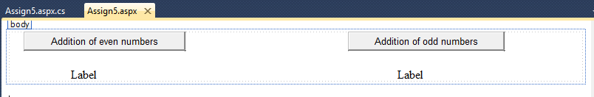

using System;

using System.Collections.Generic;

using System.Linq;

using System.Web;

using System.Web.UI;

using System.Web.UI.WebControls;

namespace Assign5

{

public partial class Assign5 : System.Web.UI.Page

{

protected void Page_Load(object sender, EventArgs e)

{

}

protected void Button1_Click(object sender, EventArgs e)

{

int sum = 0;

int number = 100;

for (int i = 0; i <= number; i += 2)

{

sum += i;

}

Label1.Text = "result for even number";

Label2.Text = sum.ToString();

}

protected void Button2_Click(object sender, EventArgs e)

{

int sum = 0;

int number = 100;

for (int i = 1; i <= number; i += 2)

{

sum += i;

}

Label1.Text = "result for odd number";

Label2.Text = sum.ToString();

}

}

}

**\*\*\*\*\*\*\*\*\*\*\*\*\*\*\*\*\*\*\*\*\*\*\*\*\*\*\*\*\*\*\*\*\*OUTPUT\*\*\*\*\*\*\*\*\*\*\*\*\*\*\*\*\*\*\*\*\*\*\*\*\*\*\*\*\*\*\*\*\***

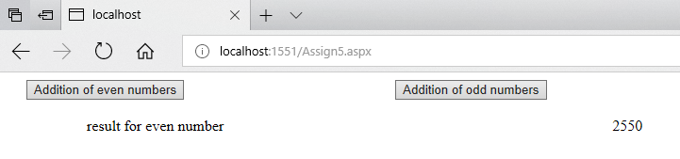

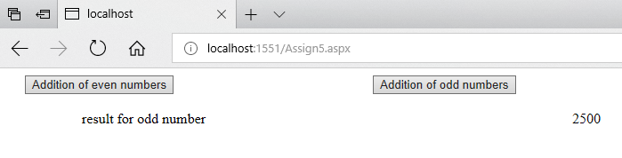

**\*\*\*\*\*\*\*\*\*\*\*\*\*\*\*\*\*\*\*\*\*\*\*\*\*\*\*\*\*\*\*\*\*\*\*\*\*\*\*\*\*\*\*\*\*\*\*\*\*\*\*\*\*\*\*\*\*\*\*\*\*\*\*\*\*\*\*\*\*\*\*\*\*\*\* Assignment No. 06**

**Name of Student:** Rupesh Ramesh Desai **Roll No.:**

**Class:** B.Sc III **Date: / /**

**Signature:**

**\*\*\*\*\*\*\*\*\*\*\*\*\*\*\*\*\*\*\*\*\*\*\*\*\*\*\*\*\*\*\*\*\*\*\*\*\*\*\*\*\*\*\*\*\*\*\*\*\*\*\*\*\*\*\*\*\*\*\*\*\*\*\*\*\*\*\*\*\*\*\*\*\*\*\***

**Q. Write an ASP.Net Program to add the value of TextBox in to DropDown List and List box Controls.**

**Program:**

<%@ Page Language="C#" AutoEventWireup="true" CodeBehind="assign6.aspx.cs" Inherits="Assign_6.assign6" %>

<!DOCTYPE html PUBLIC "-//W3C//DTD XHTML 1.0 Transitional//EN" "http://www.w3.org/TR/xhtml1/DTD/xhtml1-transitional.dtd">

<html xmlns="http://www.w3.org/1999/xhtml">

<head runat="server">

<title></title>

</head>

<body>

<form id="form1" runat="server">

<div>

<%

Response.Write("Dr.Ghali College,Gadhinglaj");

%>

<br />

<%

Response.Write("Add Class Name");

%><br />

<asp:TextBox ID="TextBox1" runat="server"></asp:TextBox>

</div>

<p>

&nbsp;</p>

<asp:DropDownList ID="DropDownList1" runat="server" Width="152px">

</asp:DropDownList>

<p>

&nbsp;</p>

<asp:Button ID="Button1" runat="server" onclick="Button1_Click" Text="Add" />

<p>

&nbsp;</p>

<asp:ListBox ID="ListBox1" runat="server" Width="149px"></asp:ListBox>

<br />

<br />

<br />

<br />

<asp:Button ID="Button2" runat="server" onclick="Button2_Click" Text="Add" />

</form>

</body>

</html>

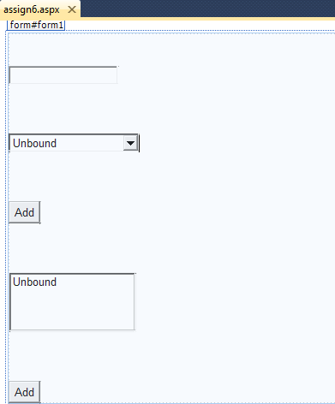

using System;

using System.Collections.Generic;

using System.Linq;

using System.Web;

using System.Web.UI;

using System.Web.UI.WebControls;

namespace Assign_6

{

public partial class assign6 : System.Web.UI.Page

{

protected void Page_Load(object sender, EventArgs e)

{

}

protected void Button1_Click(object sender, EventArgs e)

{

DropDownList1.Items.Add(TextBox1.Text);

}

protected void Button2_Click(object sender, EventArgs e)

{

ListBox1.Items.Add(DropDownList1.Text);

}

}

}

**\*\*\*\*\*\*\*\*\*\*\*\*\*\*\*\*\*\*\*\*\*\*\*\*\*\*\*\*\*\*\*\*\*OUTPUT\*\*\*\*\*\*\*\*\*\*\*\*\*\*\*\*\*\*\*\*\*\*\*\*\*\*\*\*\*\*\*\*\***

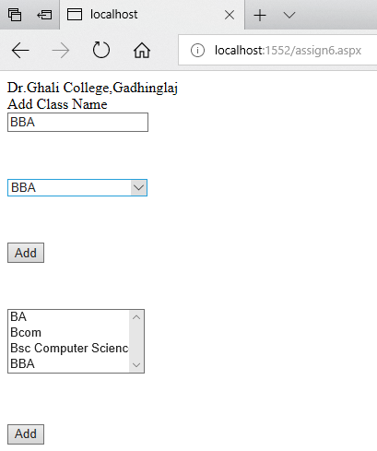

**\*\*\*\*\*\*\*\*\*\*\*\*\*\*\*\*\*\*\*\*\*\*\*\*\*\*\*\*\*\*\*\*\*\*\*\*\*\*\*\*\*\*\*\*\*\*\*\*\*\*\*\*\*\*\*\*\*\*\*\*\*\*\*\*\*\*\*\*\*\*\*\*\*\*\* Assignment No. 07**

**Name of Student:** Rupesh Ramesh Desai **Roll No.:**

**Class:** B.Sc III **Date: / /**

**Signature:**

**\*\*\*\*\*\*\*\*\*\*\*\*\*\*\*\*\*\*\*\*\*\*\*\*\*\*\*\*\*\*\*\*\*\*\*\*\*\*\*\*\*\*\*\*\*\*\*\*\*\*\*\*\*\*\*\*\*\*\*\*\*\*\*\*\*\*\*\*\*\*\*\*\*\*\***

**Q. Write an Asp.Net program to delete items from dropdown list and list box.**

**Program:**

<%@ Page Language="C#" AutoEventWireup="true" CodeBehind="assign7.aspx.cs" Inherits="Assiognment7.assign7" %>

<!DOCTYPE html PUBLIC "-//W3C//DTD XHTML 1.0 Transitional//EN" "http://www.w3.org/TR/xhtml1/DTD/xhtml1-transitional.dtd">

<html xmlns="http://www.w3.org/1999/xhtml">

<head runat="server">

<title></title>

</head>

<body>

<form id="form1" runat="server">

<div>

<%

Response.Write("Dr.Ghali College"); %>

<br />

<%

Response.Write("Add Class Name"); %>

<br />

<asp:TextBox ID="TextBox1" runat="server"></asp:TextBox>

<br />

<br />

<asp:DropDownList ID="DropDownList1" runat="server" Height="16px" Width="151px">

</asp:DropDownList>

<br />

<br />

<asp:Button ID="Button1" runat="server" onclick="Button1_Click" Text="Add" />

&nbsp;&nbsp;&nbsp;&nbsp;&nbsp;&nbsp;&nbsp;&nbsp;&nbsp;&nbsp;

<asp:Button ID="Button2" runat="server" onclick="Button2_Click" Text="Remove" />

<br />

<br />

<asp:ListBox ID="ListBox1" runat="server"></asp:ListBox>

<br />

<br />

<br />

<asp:Button ID="Button3" runat="server" onclick="Button3_Click" Text="Add" />

&nbsp;&nbsp;&nbsp;&nbsp;&nbsp;&nbsp;&nbsp;&nbsp;&nbsp;&nbsp;&nbsp;&nbsp;&nbsp;&nbsp;&nbsp;&nbsp;

<asp:Button ID="Button4" runat="server" onclick="Button4_Click" Text="Remove" />

</div>

</form>

</body>

</html>

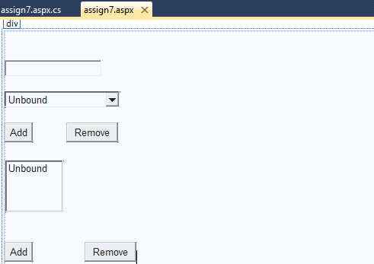

using System;

using System.Collections.Generic;

using System.Linq;

using System.Web;

using System.Web.UI;

using System.Web.UI.WebControls;

namespace Assiognment7

{

public partial class assign7 : System.Web.UI.Page

{

protected void Page_Load(object sender, EventArgs e)

{

}

protected void Button1_Click(object sender, EventArgs e)

{

DropDownList1.Items.Add(TextBox1.Text);

}

protected void Button2_Click(object sender, EventArgs e)

{

DropDownList1.Items.Remove(TextBox1.Text);

}

protected void Button3_Click(object sender, EventArgs e)

{

ListBox1.Items.Add(TextBox1.Text);

}

protected void Button4_Click(object sender, EventArgs e)

{

ListBox1.Items.Remove(TextBox1.Text);

}

}

}

**\*\*\*\*\*\*\*\*\*\*\*\*\*\*\*\*\*\*\*\*\*\*\*\*\*\*\*\*\*\*\*\*\*OUTPUT\*\*\*\*\*\*\*\*\*\*\*\*\*\*\*\*\*\*\*\*\*\*\*\*\*\*\*\*\*\*\*\*\***

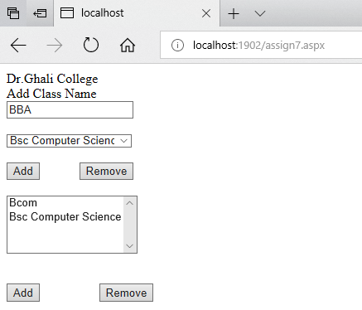

*************************************************************************** **Assignment No-8**

**Name of Student**: Rupesh Ramesh Desai **Roll No**.:

**Class**: B.Sc III **Date:** / /

**Signature:**

***************************************************************************

**Q. Write an ASP.Net Program to set Image Control according to selection of image name from dropdown list.**

**Program:**

<%@ Page Language="C#" AutoEventWireup="true" CodeBehind="Assignment-8.aspx.cs" Inherits="Assignment_8.Assignment_8" %>

<!DOCTYPE html PUBLIC "-//W3C//DTD XHTML 1.0 Transitional//EN" "http://www.w3.org/TR/xhtml1/DTD/xhtml1-transitional.dtd">

<html xmlns="http://www.w3.org/1999/xhtml">

<head runat="server">

<title></title>

</head>

<body>

<form id="form1" runat="server">

<div>

Select Any Name:

<asp:DropDownList ID="DropDownList1" runat="server"

style="height: 22px; width: 77px" AutoPostBack="True"

onselectedindexchanged="DropDownList1_SelectedIndexChanged">

</asp:DropDownList>

<br />

<br />

<br />

<asp:Image ID="Image1" runat="server" Height="227px" Width="379px" />

</div>

</form>

</body>

</html>

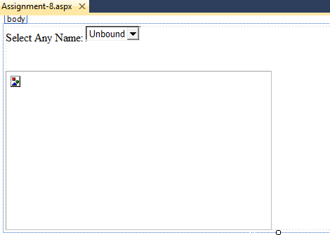

using System;

using System.Collections.Generic;

using System.Linq;

using System.Web;

using System.Web.UI;

using System.Web.UI.WebControls;

namespace Assignment_8

{

public partial class Assignment_8 : System.Web.UI.Page

{

protected void Page_Load(object sender, EventArgs e)

{

if (!Page.IsPostBack)

{

string[] str = new string[] { "select", "image1", "image2", "image3", "image4" };

for (int i = 0; i < str.Length; i++)

{

DropDownList1.Items.Add(str[i]);

}

}

}

protected void DropDownList1_SelectedIndexChanged(object sender, EventArgs e)

{

string str = DropDownList1.Text;

Image1.ImageUrl = "~/Images/" + str + ".jpg";

}

}

}

**\*\*\*\*\*\*\*\*\*\*\*\*\*\*\*\*\*\*\*\*\*\*\*\*\*\*\*\*\*\*\*\*\*OUTPUT\*\*\*\*\*\*\*\*\*\*\*\*\*\*\*\*\*\*\*\*\*\*\*\*\*\*\*\*\*\*\*\*\***

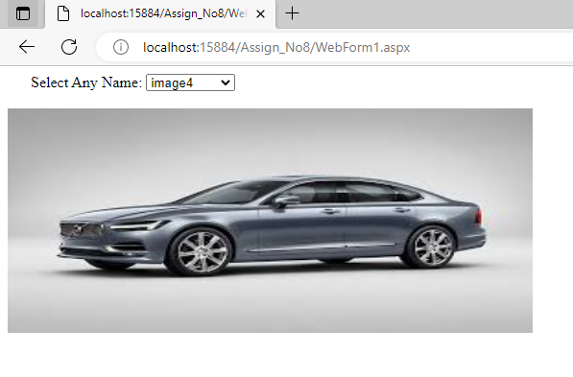

**\*\*\*\*\*\*\*\*\*\*\*\*\*\*\*\*\*\*\*\*\*\*\*\*\*\*\*\*\*\*\*\*\*\*\*\*\*\*\*\*\*\*\*\*\*\*\*\*\*\*\*\*\*\*\*\*\*\*\*\*\*\*\*\*\*\*\*\*\*\*\*\*\*\*\***

# Assignment No. 09

**Name of Student:** Rupesh Ramesh Desai **Roll No.:**

**Class:** B.Sc III  **Date: / /**

**Signature:**

**\*\*\*\*\*\*\*\*\*\*\*\*\*\*\*\*\*\*\*\*\*\*\*\*\*\*\*\*\*\*\*\*\*\*\*\*\*\*\*\*\*\*\*\*\*\*\*\*\*\*\*\*\*\*\*\*\*\*\*\*\*\*\*\*\*\*\*\*\*\*\*\*\*\*\***

**Q. Write an Asp.Net Program to demonstrate use of Master Page.**

**Program:**

Master Page:

<%@ Master Language="C#" AutoEventWireup="true" CodeFile="MasterNew.master.cs" Inherits="MasterNew" %>

<!DOCTYPE html PUBLIC "-//W3C//DTD XHTML 1.0 Transitional//EN" "http://www.w3.org/TR/xhtml1/DTD/xhtml1-transitional.dtd">

<html xmlns="http://www.w3.org/1999/xhtml">

<head runat="server">

<title>Dr Ghali College, Gadhinglaj</title>

<asp:ContentPlaceHolder id="head" runat="server">

</asp:ContentPlaceHolder>

<style type="text/css">

.style1

{

width: 104px;

}

.style2

{

width: 613px;

}

.style3

{

width: 613px;

height: 23px;

}

</style>

</head>

<body>

<form id="form1" runat="server">

<div style="background-color: #CC99FF">

<asp:HyperLink ID="HyperLink1" runat="server" NavigateUrl="~/Home.aspx"

Width="27%">Home</asp:HyperLink>

<asp:HyperLink ID="HyperLink2" runat="server" NavigateUrl="~/AboutUS.aspx"

Width="35%">About Us</asp:HyperLink>

<asp:HyperLink ID="HyperLink3" runat="server" NavigateUrl="~/ContactUS.aspx"

Width="37%">Contact Us</asp:HyperLink>

<br />

</div>

<div>

<table style="width: 100%; height: 44px;">

<tr>

<td class="style1" rowspan="3">

&nbsp;</td>

<td class="style3" align="center"

style="background-color: #ffffcc; color: #CC00CC; font-size: xx-large;" >

&nbsp;&nbsp;<asp:Image ID="Image1" runat="server" Height="78px" ImageUrl="~/Image/GhaliLogo.jpg"

Width="525px" />

</td>

<td rowspan="3">

&nbsp;</td>

</tr>

<tr>

<td class="style2">

<asp:ContentPlaceHolder ID="ContentPlaceHolder1" runat="server">

</asp:ContentPlaceHolder>

</td>

</tr>

<tr>

<td class="style2">

&nbsp;</td>

</tr>

</table>

</div>

<div style="background-color: #CC0099">

copyright @2023</div>

</form>

</body>

</html>

Home Page:

<%@ Page Title="" Language="C#" MasterPageFile="~/MasterNew.master" AutoEventWireup="true" CodeFile="Home.aspx.cs" Inherits="Home" %>

<asp:Content ID="Content1" ContentPlaceHolderID="head" Runat="Server">

</asp:Content>

<asp:Content ID="Content2" ContentPlaceHolderID="ContentPlaceHolder1" Runat="Server">

<p style="font-size: xx-large; background-color: #FF66FF">

Welcome to Dr Gahli College, Gadhinglaj </p>

</asp:Content>

About Us Page:

<%@ Page Title="" Language="C#" MasterPageFile="~/MasterNew.master" AutoEventWireup="true" CodeFile="AboutUS.aspx.cs" Inherits="AboutUS" %>

<asp:Content ID="Content1" ContentPlaceHolderID="head" Runat="Server">

</asp:Content>

<asp:Content ID="Content2" ContentPlaceHolderID="ContentPlaceHolder1" Runat="Server">

<p style="font-size: xx-large" >

Welcome to Ghali College

Dr. Ghali College is known for its name in the qualities of knowledge, punctuality, scholarships, many-fold awareness and grace in everything.

It is not we, but the people say that it is the best college for the Students coming from rural areas.

Located in convenient, calm and peaceful area, the college has been the pride of the people.

The communities living in rural and urban areas and the hill side villagers have made our college the first choice to educate their wads.

&nbsp;</p>

</asp:Content>

Contact Us Page:

<%@ Page Title="" Language="C#" MasterPageFile="~/MasterNew.master" AutoEventWireup="true" CodeFile="ContactUS.aspx.cs" Inherits="ContactUS" %>

<asp:Content ID="Content1" ContentPlaceHolderID="head" Runat="Server">

</asp:Content>

<asp:Content ID="Content2" ContentPlaceHolderID="ContentPlaceHolder1" Runat="Server">

<p style="font-size: x-large">

Address:- Bhadagaon Road, Gadhinglaj

Tal : Gadhinglaj, Dist : Kolhapur, Maharashtra-416526

Principal : +91 9421112626

Phone : 2327 222119

Fax : 2327 224419

Email : drghalicollege@gmail.com

Website: www.ghalicollege.edu.in</p>

</asp:Content>

**\*\*\*\*\*\*\*\*\*\*\*\*\*\*\*\*\*\*\*\*\*\*\*\*\*\*\*\*\*\*\*\*\*OUTPUT\*\*\*\*\*\*\*\*\*\*\*\*\*\*\*\*\*\*\*\*\*\*\*\*\*\*\*\*\*\*\*\*\***

**Home:**

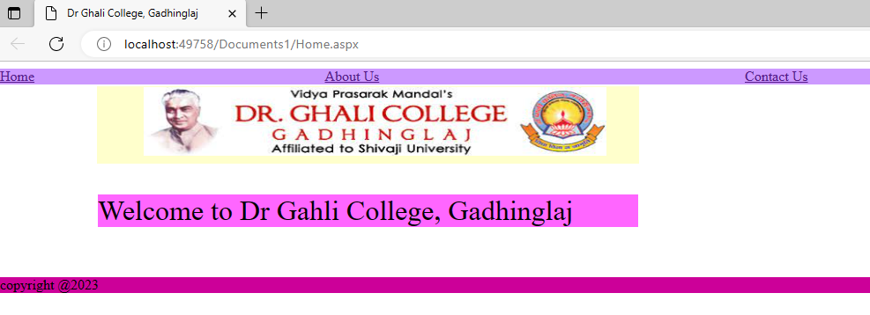

**About Us:**



**Contact Us:**

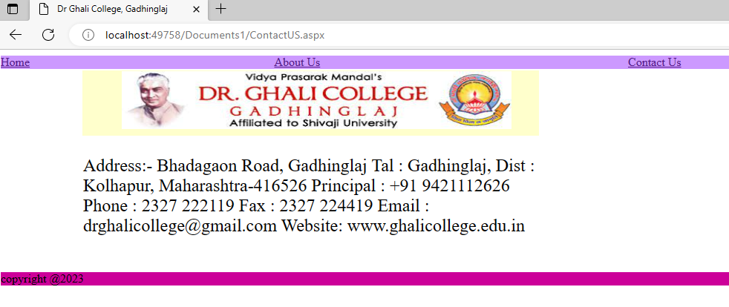

**\*\*\*\*\*\*\*\*\*\*\*\*\*\*\*\*\*\*\*\*\*\*\*\*\*\*\*\*\*\*\*\*\*\*\*\*\*\*\*\*\*\*\*\*\*\*\*\*\*\*\*\*\*\*\*\*\*\*\*\*\*\*\*\*\*\*\*\*\*\*\*\*\*\*\***

# Assignment No. 10

**Name of Student:** Rupesh Ramesh Desai **Roll No.:**

**Class:** B.Sc III  **Date: / /**

**Signature:**

**\*\*\*\*\*\*\*\*\*\*\*\*\*\*\*\*\*\*\*\*\*\*\*\*\*\*\*\*\*\*\*\*\*\*\*\*\*\*\*\*\*\*\*\*\*\*\*\*\*\*\*\*\*\*\*\*\*\*\*\*\*\*\*\*\*\*\*\*\*\*\*\*\*\*\***

**Q. Program to demonstrate ADO.Net connected architecture.**

**Program:**

using System;

using System.Collections.Generic;

using System.ComponentModel;

using System.Data;

using System.Drawing;

using System.Linq;

using System.Text;

using System.Threading.Tasks;

using System.Windows.Forms;

using System.Data.OleDb;

namespace WindowsFormsApplication1

{

public partial class Form1 : Form

{

OleDbConnection cn;

OleDbCommand cmd;

OleDbDataReader dread;

public Form1()

{

InitializeComponent();

}

public void connection ()

{

string str =("Provider=Microsoft.ACE.OLEDB.12.0;Data Source=D:\\Student.accdb");

cn= new OleDbConnection (str);

cn.Open ();

}

private void button1_Click(object sender, EventArgs e)

{

connection();

MessageBox.Show ("Connection Successfully");

}

private void button2_Click(object sender, EventArgs e)

{

connection ();

cmd=new OleDbCommand ("insert into stud values ('"+textBox1 .Text +"','"+textBox2 .Text +"','"+textBox3 .Text +"','"+textBox4 .Text +"','"+textBox5 .Text +"')",cn );

cmd .ExecuteNonQuery ();

MessageBox .Show ("Record save successfully");

}

private void button3_Click(object sender, EventArgs e)

{

cmd =new OleDbCommand ("delete from stud where rno==" +textBox1 .Text ,cn);

cmd .ExecuteNonQuery ();

MessageBox .Show ("Record delete successfully");

}

private void button4_Click(object sender, EventArgs e)

{

connection ();

cmd=new OleDbCommand ("select * from stud where rno="+textBox1 .Text ,cn);

dread =cmd.ExecuteReader();

while (dread .Read ())

{

textBox2 .Text =dread [1].ToString ();

textBox3 .Text =dread [2].ToString ();

textBox4 .Text =dread [3].ToString ();

textBox5 .Text =dread [4].ToString ();

}

dread .Close ();

}

private void button5_Click(object sender, EventArgs e)

{

Application .Exit ();

}

private void button6_Click(object sender, EventArgs e)

{

connection ();

cmd= new OleDbCommand ("update stud set sname='"+textBox2 .Text +"',saddress='"+textBox3 .Text +"',sclass='"+textBox4 .Text +"',marks='"+textBox5 .Text +"' where rno= "+textBox1 .Text ,cn);

MessageBox .Show ("Record update Successfully");

}

private void button7_Click(object sender, EventArgs e)

{

textBox1 .Clear ();

textBox2 .Clear ();

textBox3 .Clear ();

textBox4 .Clear ();

textBox5 .Clear ();

}

}

}

**\*\*\*\*\*\*\*\*\*\*\*\*\*\*\*\*\*\*\*\*\*\*\*\*\*\*\*\*\*\*\*\*\*OUTPUT\*\*\*\*\*\*\*\*\*\*\*\*\*\*\*\*\*\*\*\*\*\*\*\*\*\*\*\*\*\*\*\*\***

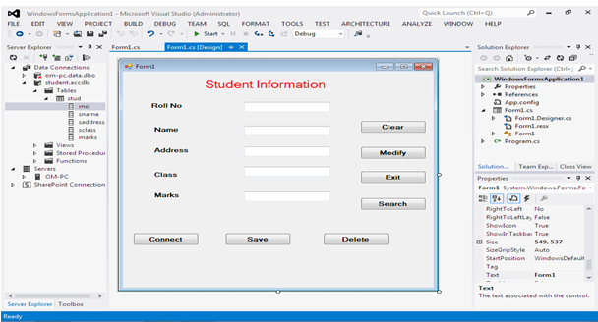

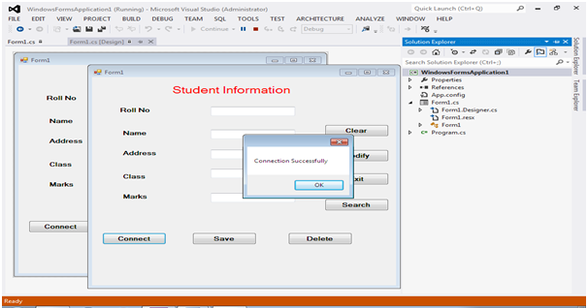

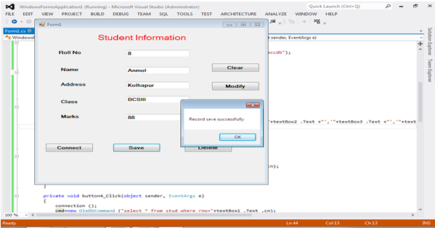

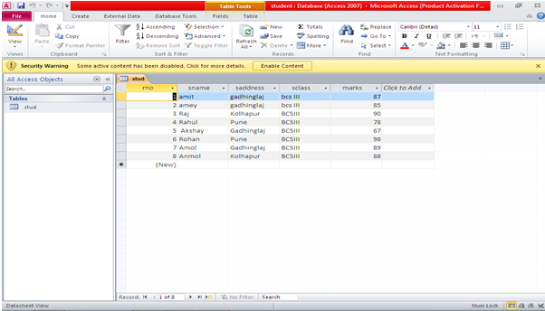

**\*\*\*\*\*\*\*\*\*\*\*\*\*\*\*\*\*\*\*\*\*\*\*\*\*\*\*\*\*\*\*\*\*\*\*\*\*\*\*\*\*\*\*\*\*\*\*\*\*\*\*\*\*\*\*\*\*\*\*\*\*\*\*\*\*\*\*\*\*\*\*\*\*\*\***

# Assignment No. 11

**Name of Student:** Rupesh Ramesh Desai **Roll No.:**

**Class:** B.Sc III  **Date: / /**

**Signature:**

**\*\*\*\*\*\*\*\*\*\*\*\*\*\*\*\*\*\*\*\*\*\*\*\*\*\*\*\*\*\*\*\*\*\*\*\*\*\*\*\*\*\*\*\*\*\*\*\*\*\*\*\*\*\*\*\*\*\*\*\*\*\*\*\*\*\*\*\*\*\*\*\*\*\*\***

**Q. Write an ADO.Net application that demonstrates disconnected architecture.**

**Program:**

using System;

using System.Collections.Generic;

using System.ComponentModel;

using System.Data;

using System.Drawing;

using System.Linq;

using System.Text;

using System.Windows.Forms;

using System.Data.OleDb;

namespace Prjconless

{

public partial class Form1 : Form

{

OleDbConnection con;

OleDbDataAdapter da;

DataSet ds=new DataSet();

DataTable dt;

DataRow dr;

DataRow[] drows;

//DataColumn dc;

OleDbCommandBuilder cb;

public Form1()

{

InitializeComponent();

}

private void B1_Click(object sender, EventArgs e)// connection

{

con = new OleDbConnection("Provider=Microsoft.ACE.OLEDB.12.0;Data Source='D:\\con less\\items.accdb';Persist Security Info=True");

con.Open();

MessageBox.Show("connection sucessfull");

ds.Tables.Add("CItems");

da = new OleDbDataAdapter("Select * from items", con);

da.Fill(ds.Tables["CItems"]);

con.Close();

}

private void B2_Click(object sender, EventArgs e) // add to client

{

dt =ds.Tables["CItems"];

dr = dt.NewRow();

dr[0] = T1.Text;

dr[1] = T2.Text;

dr[2] = T3.Text;

dr[3] = T4.Text;

dr[4] = t5.Text;

dt.Rows.Add(dr);

MessageBox.Show("Record saved in Client ds");

}

private void btnadd_Click(object sender, EventArgs e) // add to db

{

con.Open();

cb = new OleDbCommandBuilder(da);

da.InsertCommand = cb.GetInsertCommand();

da.Update(ds.Tables["CItems"]);

con.Close();

MessageBox.Show("Record saved in DB");

}

private void Form1_Load(object sender, EventArgs e)

{

con = new OleDbConnection("Provider=Microsoft.ACE.OLEDB.12.0;Data Source='D:\\con less\\items.accdb';Persist Security Info=True");

con.Open();

MessageBox.Show("connection sucessfull");

ds.Tables.Add("CItems");

da = new OleDbDataAdapter("Select * from items", con);

da.Fill(ds.Tables["CItems"]);

con.Close();

}

private void B3_Click(object sender, EventArgs e) //searchcode

{

drows = ds.Tables["CItems"].Select("ICode=" + T1.Text);

T2.Text = drows[0][1].ToString();

T3.Text = drows[0][2].ToString();

T4.Text = drows[0][3].ToString();

t5.Text = drows[0][4].ToString();

}

private void button2_Click(object sender, EventArgs e)//close

{

this.Close();

}

private void button1_Click(object sender, EventArgs e)//modify code

{

dr = drows[0];

dr.BeginEdit();

dr[1] = T2.Text;

dr[2] = T3.Text;

dr[3] = T4.Text;

dr[4] = t5.Text;

dr.EndEdit();

MessageBox.Show("Record updated in Client ds");

}

private void B4_Click(object sender, EventArgs e)//delete code

{

dr = drows[0];

dr.Delete();

MessageBox.Show("Record Delete in Client ds");

}}}

**\*\*\*\*\*\*\*\*\*\*\*\*\*\*\*\*\*\*\*\*\*\*\*\*\*\*\*\*\*\*\*\*\*OUTPUT\*\*\*\*\*\*\*\*\*\*\*\*\*\*\*\*\*\*\*\*\*\*\*\*\*\*\*\*\*\*\*\*\***

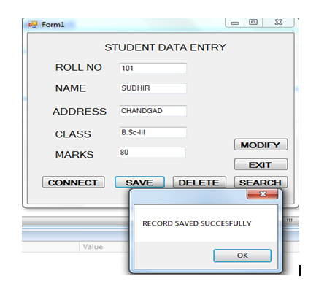

**\*\*\*\*\*\*\*\*\*\*\*\*\*\*\*\*\*\*\*\*\*\*\*\*\*\*\*\*\*\*\*\*\*\*\*\*\*\*\*\*\*\*\*\*\*\*\*\*\*\*\*\*\*\*\*\*\*\*\*\*\*\*\*\*\*\*\*\*\*\*\*\*\*\*\***

# Assignment No. 12

**Name of Student:** Rupesh Ramesh Desai **Roll No.:**

**Class:** B.Sc III  **Date: / /**

**Signature:**

**\*\*\*\*\*\*\*\*\*\*\*\*\*\*\*\*\*\*\*\*\*\*\*\*\*\*\*\*\*\*\*\*\*\*\*\*\*\*\*\*\*\*\*\*\*\*\*\*\*\*\*\*\*\*\*\*\*\*\*\*\*\*\*\*\*\*\*\*\*\*\*\*\*\*\***

**Q. Program to demonstrate client side state management.**

**Program:**

<%@ Page Language="C#" AutoEventWireup="true" CodeFile="Default2.aspx.cs" Inherits="Default2" %>

<!DOCTYPE html>

<html xmlns="http://www.w3.org/1999/xhtml">

<head runat="server">

<title></title>

</head>

<body>

<form id="form1" runat="server">

<div>

&nbsp;&nbsp;&nbsp;&nbsp; User Registration Form<br />

<br />

<br />

<asp:Label ID="Label1" runat="server" Text="User Name"></asp:Label>

&nbsp;&nbsp;&nbsp;&nbsp;&nbsp;&nbsp;&nbsp;

<asp:TextBox ID="TextBox1" runat="server"></asp:TextBox>

&nbsp;&nbsp;&nbsp;&nbsp;&nbsp;&nbsp;&nbsp;

<asp:RequiredFieldValidator ID="RequiredFieldValidator1" runat="server" ControlToValidate="TextBox1" ErrorMessage="please enter name"></asp:RequiredFieldValidator>

<br />

<br />

<asp:Label ID="Label2" runat="server" Text="Password"></asp:Label>

&nbsp;&nbsp;&nbsp;&nbsp;&nbsp;&nbsp;&nbsp;&nbsp;&nbsp;&nbsp;

<asp:TextBox ID="TextBox2" runat="server" TextMode="Password"></asp:TextBox>

&nbsp;&nbsp;&nbsp;&nbsp;&nbsp;&nbsp;&nbsp;

<asp:RequiredFieldValidator ID="RequiredFieldValidator2" runat="server" ControlToValidate="TextBox2" ErrorMessage="enter password"></asp:RequiredFieldValidator>

<br />

<br />

<asp:Label ID="Label3" runat="server" Text="Email"></asp:Label>

&nbsp;&nbsp;&nbsp;&nbsp;&nbsp;&nbsp;&nbsp;&nbsp;&nbsp;&nbsp;&nbsp;&nbsp;&nbsp;&nbsp;&nbsp;&nbsp;&nbsp;

<asp:TextBox ID="TextBox3" runat="server"></asp:TextBox>

&nbsp;&nbsp;&nbsp;&nbsp;&nbsp;&nbsp;&nbsp;

<asp:RegularExpressionValidator ID="RegularExpressionValidator1" runat="server" ControlToValidate="TextBox3" ErrorMessage="enter email" ValidationExpression="\w+([-+.']\w+)*@\w+([-.]\w+)*\.\w+([-.]\w+)*"></asp:RegularExpressionValidator>

<br />

<br />

<asp:Label ID="Label4" runat="server" Text="Contact"></asp:Label>

&nbsp;&nbsp;&nbsp;&nbsp;&nbsp;&nbsp;&nbsp;&nbsp;&nbsp;&nbsp;&nbsp;&nbsp;&nbsp;

<asp:TextBox ID="TextBox4" runat="server"></asp:TextBox>

&nbsp;&nbsp;&nbsp;&nbsp;&nbsp;&nbsp;&nbsp;

<asp:RequiredFieldValidator ID="RequiredFieldValidator3" runat="server" ControlToValidate="TextBox4" ErrorMessage="enter contact number"></asp:RequiredFieldValidator>

<br />

<br />

<br />

&nbsp;&nbsp;&nbsp;&nbsp;&nbsp;&nbsp;&nbsp;&nbsp;&nbsp;&nbsp;&nbsp;&nbsp;

<asp:Button ID="Button1" runat="server" Text="Save" />

&nbsp;&nbsp;&nbsp;&nbsp;&nbsp;&nbsp;&nbsp;&nbsp;&nbsp;&nbsp;&nbsp;

<asp:Button ID="Button2" runat="server" Text="Cancel" />

</div>

</form>

</body>

</html>

**\*\*\*\*\*\*\*\*\*\*\*\*\*\*\*\*\*\*\*\*\*\*\*\*\*\*\*\*\*\*\*\*\*OUTPUT\*\*\*\*\*\*\*\*\*\*\*\*\*\*\*\*\*\*\*\*\*\*\*\*\*\*\*\*\*\*\*\*\***

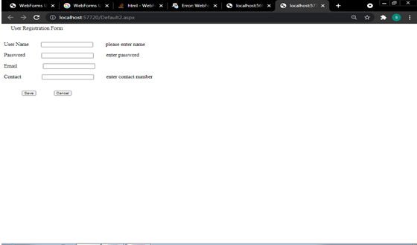

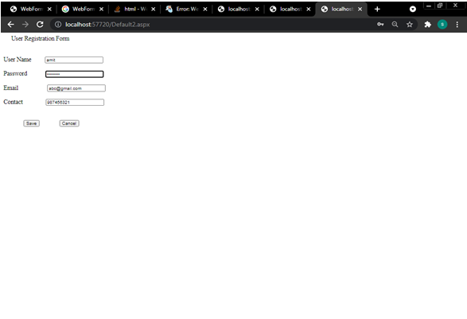

**\*\*\*\*\*\*\*\*\*\*\*\*\*\*\*\*\*\*\*\*\*\*\*\*\*\*\*\*\*\*\*\*\*\*\*\*\*\*\*\*\*\*\*\*\*\*\*\*\*\*\*\*\*\*\*\*\*\*\*\*\*\*\*\*\*\*\*\*\*\*\*\*\*\*\***

# Assignment No. 13

**Name of Student:** Rupesh Ramesh Desai **Roll No.:**

**Class:** B.Sc III  **Date: / /**

**Signature:**

**\*\*\*\*\*\*\*\*\*\*\*\*\*\*\*\*\*\*\*\*\*\*\*\*\*\*\*\*\*\*\*\*\*\*\*\*\*\*\*\*\*\*\*\*\*\*\*\*\*\*\*\*\*\*\*\*\*\*\*\*\*\*\*\*\*\*\*\*\*\*\*\*\*\*\***

**Q. Write an Asp.Net Program to perform search and delete operation in database.**

<%@ Page Language="C#" AutoEventWireup="true" CodeFile="Default.aspx.cs" Inherits="_Default" %>

<!DOCTYPE html PUBLIC "-//W3C//DTD XHTML 1.0 Transitional//EN" "<http://www.w3.org/TR/xhtml1/DTD/xhtml1-transitional.dtd>">

<html xmlns="http://www.w3.org/1999/xhtml">

<head runat="server">

<title>Untitled Page</title>

<style type="text/css">

.style1

{

width: 37%;

}

.style2

{

height: 24px;

width: 89px;

}

.style3

{

width: 139px;

}

.style4

{

height: 24px;

width: 139px;

}

.style5

{

width: 89px;

}

</style>

</head>

<body>

<form id="form1" runat="server">

<div>

<table class="style1">

<tr>

<td class="style3">

<asp:Label ID="Label2" runat="server" Font-Bold="True" Text="StudentId"></asp:Label>

</td>

<td class="style5">

<asp:TextBox ID="TextBox1" runat="server"></asp:TextBox>

</td>

</tr>

<tr>

<td class="style3">

<asp:Label ID="Label5" runat="server" Font-Bold="True" Text="Class"></asp:Label>

</td>

<td class="style5">

<asp:TextBox ID="TextBox2" runat="server"></asp:TextBox>

</td>

</tr>

<tr>

<td class="style4">

<asp:Label ID="Label4" runat="server" Font-Bold="True" Text="Name"></asp:Label>

</td>

<td class="style2">

<asp:TextBox ID="TextBox3" runat="server"></asp:TextBox>

</td>

</tr>

<tr>

<td class="style3">

<span lang="en-us">&nbsp;<asp:Label ID="Label7" runat="server" Font-Bold="True"

Text="Address"></asp:Label>

</span>

</td>

<td class="style5">

<asp:TextBox ID="TextBox4" runat="server"></asp:TextBox>

</td>

</tr>

</table>

</div>

<p>

<span lang="en-us">&nbsp;&nbsp;&nbsp;&nbsp;&nbsp;&nbsp;&nbsp;&nbsp;&nbsp;&nbsp;&nbsp;&nbsp;&nbsp;&nbsp;&nbsp;&nbsp;&nbsp;&nbsp;&nbsp;&nbsp;&nbsp;

</span>

</p>

<p>

<asp:Button ID="Button1" runat="server" BackColor="#66CCFF" Font-Bold="True"

ForeColor="Black" onclick="Button1_Click" Text="New" />

<span lang="en-us">&nbsp;&nbsp;&nbsp;&nbsp;&nbsp;&nbsp;&nbsp;&nbsp;&nbsp;&nbsp;&nbsp; &nbsp;&nbsp;&nbsp;&nbsp;&nbsp;&nbsp;&nbsp;&nbsp;&nbsp;&nbsp;&nbsp;&nbsp;&nbsp;&nbsp;

</span>&nbsp;<asp:Button ID="Button2" runat="server" Font-Bold="True"

onclick="Button2_Click" style="height: 26px" Text="Insert" />

</p>

</form>

</body>

</html>

**Program Code :**

using System;

using System.Configuration;

using System.Data;

using System.Linq;

using System.Web;

using System.Web.Security;

using System.Web.UI;

using System.Web.UI.HtmlControls;

using System.Web.UI.WebControls;

using System.Web.UI.WebControls.WebParts;

using System.Xml.Linq;

using System.Data.SqlClient;

public partial class _Default : System.Web.UI.Page

{

SqlConnection cn = new SqlConnection(@"Data Source=.\sqlExpress;Initial Catalog=ashu;Integrated Security=True");

protected void Page_Load(object sender, EventArgs e)

{

}

protected void Button1_Click(object sender, EventArgs e)

{

cn.Open();

SqlCommand cmd = new SqlCommand("select max(StudentId) from Table4", cn);

SqlDataReader dr;

dr = cmd.ExecuteReader();

if (dr.Read())

{

if (dr.IsDBNull(0))

{

TextBox1.Text = "101";

}

else

{

TextBox1.Text = (Convert.ToInt32(dr[0]) + 1).ToString();

}

}

else

{

TextBox1.Text = "101";

}

cn.Close();

}

protected void Button2_Click(object sender, EventArgs e)

{

cn.Open();

SqlCommand cmd = new SqlCommand("insert into Table4 values('" + TextBox1.Text + "','" + TextBox2.Text + "','" + TextBox3.Text + "','" + TextBox4.Text + "')", cn);

cmd.ExecuteNonQuery();

cn.Close();

}

}

**\*\*\*\*\*\*\*\*\*\*\*\*\*\*\*\*\*\*\*\*\*\*\*\*\*\*\*\*\*\*\*\*\*OUTPUT\*\*\*\*\*\*\*\*\*\*\*\*\*\*\*\*\*\*\*\*\*\*\*\*\*\*\*\*\*\*\*\*\***

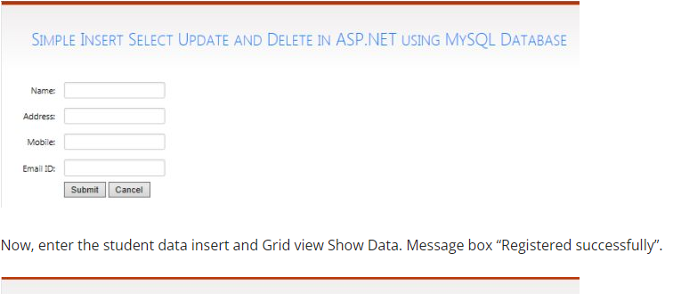

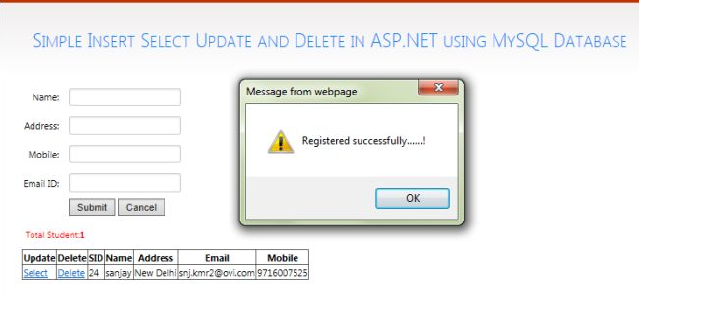

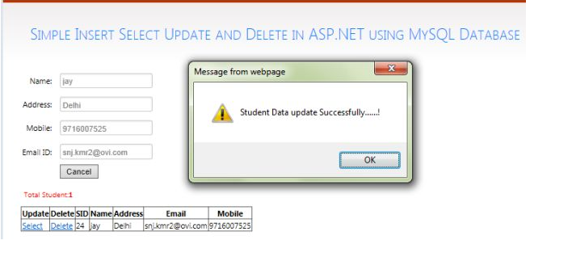

**\*\*\*\*\*\*\*\*\*\*\*\*\*\*\*\*\*\*\*\*\*\*\*\*\*\*\*\*\*\*\*\*\*\*\*\*\*\*\*\*\*\*\*\*\*\*\*\*\*\*\*\*\*\*\*\*\*\*\*\*\*\*\*\*\*\*\*\*\*\*\*\*\*\*\***

# Assignment No. 14

**Name of Student:** Rupesh Ramesh Desai **Roll No.:**

**Class:** B.Sc III  **Date: / /**

**Signature:**

**\*\*\*\*\*\*\*\*\*\*\*\*\*\*\*\*\*\*\*\*\*\*\*\*\*\*\*\*\*\*\*\*\*\*\*\*\*\*\*\*\*\*\*\*\*\*\*\*\*\*\*\*\*\*\*\*\*\*\*\*\*\*\*\*\*\*\*\*\*\*\*\*\*\*\***

**Q. Write an Asp.Net Program to display the record from database using Data Reader Object.**

**Program:**

using System;

using System.Collections.Generic;

using System.ComponentModel;

using System.Data;

using System.Drawing;

using System.Linq;

using System.Text;

using System.Threading.Tasks;

using System.Windows.Forms;

using System.Data.OleDb;

namespace WindowsFormsApplication1

{

public partial class Form1 : Form

{

OleDbConnection cn;

OleDbCommand cmd;

public Form1()

{

InitializeComponent();

}

public void connection()

{

cn = new OleDbConnection ("Provider=Microsoft.ACE.OLEDB.12.0;Data Source=D:\\BSC and BCS GER PROG2020-21\\Student.accdb");

cn.Open ();

}

private void button1_Click(object sender, EventArgs e)

{

// cn.Open ();

connection ();

cmd= new OleDbCommand ("insert into Student values("+textBox1 .Text +",'"+textBox2 .Text +"','" +textBox3 .Text +"','"+textBox4 .Text +"')",cn);

cmd.ExecuteNonQuery ();

MessageBox .Show ("Record Save Successfully");

cn.Close ();

}

private void Form1_Load(object sender, EventArgs e)

{

connection ();

}

private void button2_Click(object sender, EventArgs e)

{

connection ();

textBox1 .Text =" ";

textBox2 .Text =" ";

textBox3 .Text =" ";

textBox4 .Text =" ";

}

private void button3_Click(object sender, EventArgs e)

{

Application .Exit ();

}

}

}

**\*\*\*\*\*\*\*\*\*\*\*\*\*\*\*\*\*\*\*\*\*\*\*\*\*\*\*\*\*\*\*\*\*OUTPUT\*\*\*\*\*\*\*\*\*\*\*\*\*\*\*\*\*\*\*\*\*\*\*\*\*\*\*\*\*\*\*\*\***

